EXPERIMENT NO: 1  **BASIC LOGIC GATES** 23/01/2023

**NOT GATE**

**A=0**

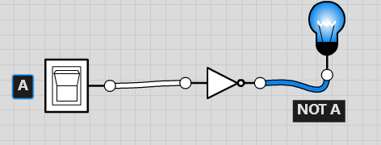

**A=1**

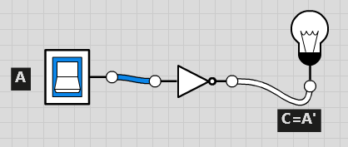

**TRUTH TABLE**

